

**Arctic Cat Catalyst 858 Lightweight Quiet Muffler (full ceramic coating)**

**Installation Instructions 131-170**

1. Remove stock muffler completely. Remove stock grommet from the stock muffler to be re-installed into the new Straightline muffler. Remove the stock temp sensor and keep stock springs to be re-installed.

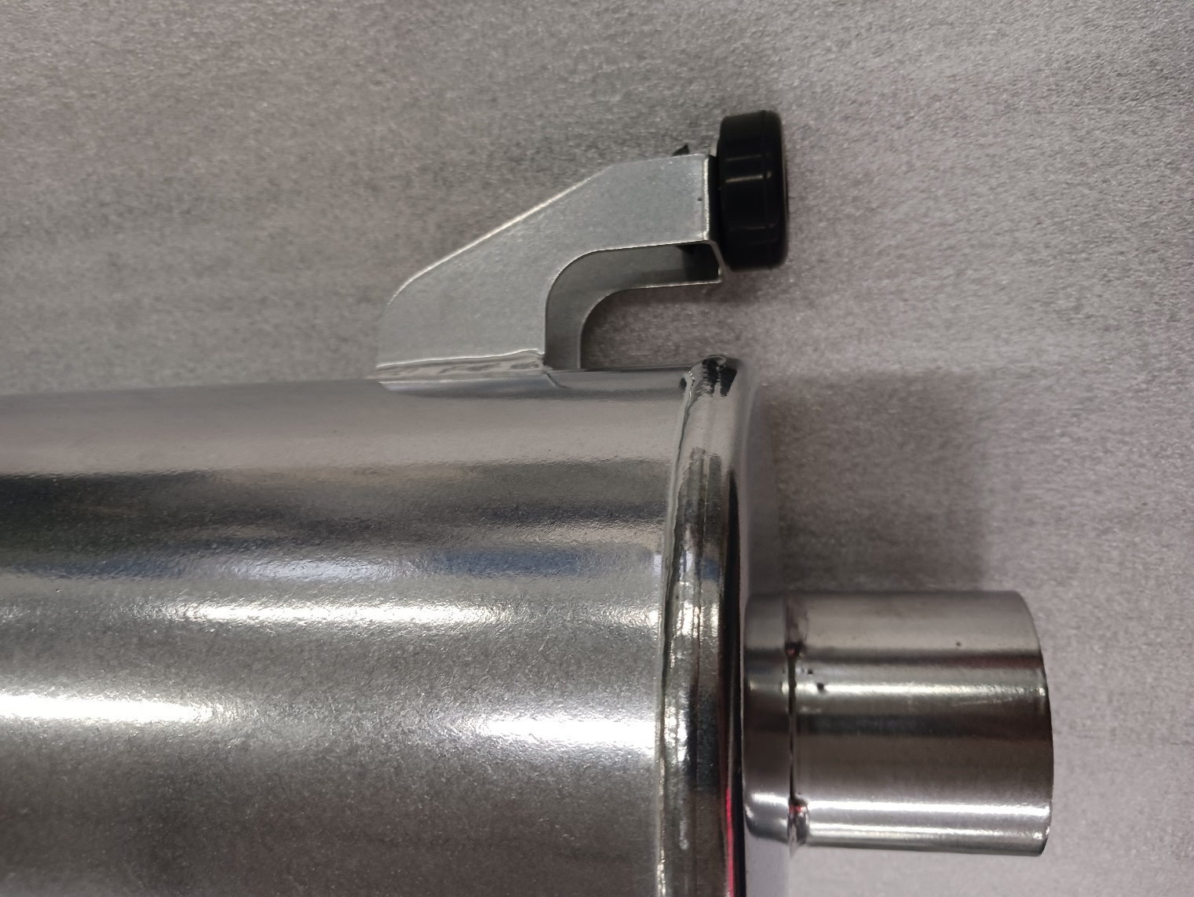

Install the stock muffler grommet as shown here. The wider part must be on the bottom. You can add a small amount of grease to ensure the grommets slide into the muffler and pins to be fully seated.

1. Install the muffler on the snowmobile by lining up the bottom mount first then push the upper mount into the upper bushing on the snowmobile.

Your stock muffler used 2 hitch pin clips and 2 large washers on the 2 upper mounting pins. The Straightline muffler only has 1 pin. Be sure to install the other clip and washers into place even though there is no mount there. This way the clip is completely installed and will not fall.

Install the washer and clip after inserting the pin from the muffler.

**Straightline Performance 651-466-0212** [**www.straightlineperformance.com**](http://www.straightlineperformance.com)

Install the muffler temp sensor back into the Straightline muffler. Be sure that the wire does not touch any of the muffler after installed.

Install the stock springs

* ***Be sure the muffler has no manufacturing defects. If the muffler has been run/used there are no warranties for fitment.***
* Jetting Requirements- No Jetting Required
* Clutching Requirements-No Clutching Required
* Facebook @ straightlineperformanceinc1 - Youtube @ straightlineperfinc - Twitter @ straightlineperf

Technical Question Please Email [tech@straightlineperformance.com](mailto:tech@straightlineperformance.com)

|  |  |  |  |
| --- | --- | --- | --- |
| **Bill of Materials** (BOM) | |  |  |
| Qty | Part Number | Description | In Box |
| 1 | 131-170 | Muffler |  |
| 1 |  | Sticker |  |
| 1 |  | Instructions |  |
|  |  |  |  |
|  |  | Checked By: |  |
|  |  |  |  |

**Straightline Performance 651-466-0212** [**www.straightlineperformance.com**](http://www.straightlineperformance.com)