Kids Bar Heater Kit (RSI-KIDS-HEATER)
Installation Instructions
- Kit contains parts required to add handlebar heaters to the Kids Bar accessory.
- Locate position for switch. Drill .8” hole and mount switch.
- On handlebar, install insulators. Use heat gun or equivalent source to heat shrink insulators to handlebar.
- Remove adhesive backing and install heat pads over heat shrink insulators. Locate wires toward center for routing.
- Install hand grips over heat pads using adhesive.
- Connect one wire from heat pad #1 to one wire from heat pad #2 using butt connector.
- Connect (+) power source to one wire of the heat pad. Either wire is acceptable
- Connect (-) power source to center terminal of switch.
- Connect remaining wire of heat pad to either remaining terminal of switch. Heat pads are wired in a series type connection.
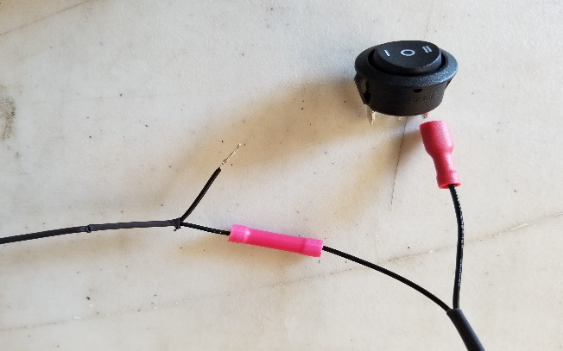
(-) ground connection from snowmobile to center terminal of switch
Connect heater pad wire #2 to (+) power source
Heater pad wire #1 connect to switch
QTY | Part Number | Description | In Box
1 | butt connector, 20-18 AWG | Butt Connector
2 | Tap Splice 22-18GA Red | Scotch Lock connectors
1 |  | Switch
2 | GH-17 ELEMENT | Grip Heater
1 | GH-L2 | Grip Insulator
1 | GG-1 | Grip Glue
2 |  | Terminals
 |  | Checked and Packaged By

LIMITED WARRANTY
RSI warrants this product to be free from defects in material and workmanship under use for the purpose it was intended. RSI shall not be liable for damage or injury caused by defective materials or workmanship. RSI may elect to repair or replace this product, but is the sole judge of any defects in their product. This warranty does not cover any labor costs to remove or reinstall this product and is effect for one year from the original purchase date.
Technical questions please email tech@straightlineperformance.com

Facebook @ straightlineperformanceinc
Youtube @ straightlineperfinc
Twitter @ straightlineperf

Straightline Performance 15250 Hornsby St Forest Lake, MN 55025 651-466-0212 www.straightlineperformance.com

